26.10.5 Editors - Properties Editor - Physics Properties Tab - Soft Body panel
Detailed table of content 2
Soft Body 4
Tips 4
Soft Body panel 5
Collision Collection 5
Object subpanel 5
Friction 5
Mass 5
Control Point 5
Simulation subpanel 5
Speed 5
Cache subpanel 6
Hints 6
Caches List 6
Add New Cache 7
Delete current Cache 7
Simulation start 7
End 7
Cache Step 7
Info string 7
Disk Cache 7
Bake / Delete Bake 8
Calculate To Frame 8
Current Cache to Bake 8
Bake All Dynamics 8
Delete All Bakes 8
Update All To Frame 8
Goal subpanel 9
Vertex Group 9
Goal Settings sub subpanel 9
Goal Strength sub subpanel 9
Edges subpanel 9
Use Edges 9
Springs 9
Pull 10
Push 10
Damp 10
Plastic 10
Bending 10
Length 10
Collision Edge 10
Face 10
Aerodynamics sub subpanel 10
Stiffness sub subpanel 11
Self Collision subpanel 11
Calculation Type 11
Ball Size 12
Stiffness 12
Dampening 12
Solver subpanel 12
Step Size Min 12
Max 12
Auto-Step 12
Error Limit 12
Field Weights subpanel 13

Detailed table of content
Detailed table of content
Detailed table of content 2
Soft Body 4
Tips 4
Soft Body panel 5
Collision Collection 5
Object subpanel 5
Friction 5
Mass 5
Control Point 5
Simulation subpanel 5
Speed 5
Cache subpanel 6
Hints 6
Caches List 6
Drag Handler 7
Search Field 7
Invert 7
Sort by Name 7
Add New Cache 7
Delete current Cache 7
Simulation start 7
End 7
Cache Step 7
Info string 7
Disk Cache 7
Use Library Path 7
Compression 8
None 8
Light 8
Heavy 8
Bake / Delete Bake 8
Calculate To Frame 8
Current Cache to Bake 8
Bake All Dynamics 8
Delete All Bakes 8
Update All To Frame 8
Goal subpanel 9
Vertex Group 9
Goal Settings sub subpanel 9
Stiffness 9
Damping 9
Goal Strength sub subpanel 9
Default 9
Min / Max 9
Edges subpanel 9
Use Edges 9
Springs 9
Pull 10
Push 10
Damp 10
Plastic 10
Bending 10
Length 10
Collision Edge 10
Face 10
Aerodynamics sub subpanel 10
Type 11
Simple 11
Lift Force 11
Factor 11
Stiffness sub subpanel 11
Shear 11
Self Collision subpanel 11
Calculation Type 11
Manual 11
Average 11
Minimal / Maximal 11
Average Min Max 11
Ball Size 12
Stiffness 12
Dampening 12
Solver subpanel 12
Step Size Min 12
Max 12
Auto-Step 12
Error Limit 12
Diagnostics sub subpanel 13
Print Performance to Console 13
Estimate Matrix 13
Helpers sub subpanel 13
Choke 13
Fuzzy 13
Field Weights subpanel 13

Soft Body

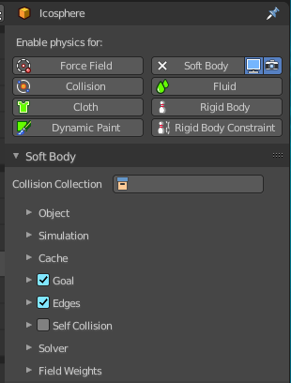
Soft body simulation is used for simulating soft deformable objects. It was designed primarily for adding secondary motion to animation, like jiggle for body parts of a moving character.

It also works for simulating more general soft objects that bend, deform and react to forces like gravity and wind, or collide with other objects.

The soft body simulation works by combining existing animation on the object with forces acting on it. There are exterior forces like gravity or force fields and interior forces that hold the vertices together. This way you can simulate the shapes that an object would take on in reality if it had volume, was filled with something, and was acted on by real forces.

Soft bodies can interact with other objects through Collision. They can interact with themselves through Self-Collision.

The result of the soft body simulation can be converted to a static object. You can also bake edit the simulation, means edit intermediate results and run the simulation from there.

Soft bodies can be used for:
- Jiggle on moving characters.
- Elastic and deformable objects made of materials like rubber or gelatin.
- Tree branches moving in the wind, swinging ropes, and the like.
- Flags, wide sleeves, cushions or other simple fabric reacting to forces.

Soft body simulation works for all objects that have vertices or control points (meshes, curves, surfaces, and lattices).

Soft body simulation is a dynamic effect. It needs an animation.

Tips
Soft bodies work especially well if the objects have an even vertex distribution. You need enough vertices for good collisions. You change the deformation (the stiffness) if you add more vertices in a certain region.

The calculation of collisions may take a long time. If something is not visible, why calculate it?

To speed up the collision calculation it is often useful to collide with an additional, simpler, invisible, somewhat larger object.

Use soft bodies only where it makes sense. If you try to cover a body mesh with a tight piece of cloth and animate solely with soft body, you will have no success. Self-collision of soft body hair may be activated, but that is a path that you have to wander alone. We will deal with Collisions in detail later.

Try and use a Lattice or a Curve Guide soft body instead of the object itself. This may be magnitudes faster.

Soft Body panel

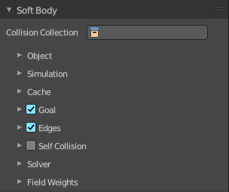

Collision Collection
Limit the soft body simulation to objects in a collection

Object subpanel

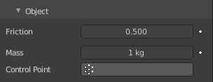

Friction
The friction of the surrounding medium. Generally friction dampens a movement. The larger the friction, the more viscous is the medium. Friction always appears when a vertex moves relative to its surround medium.

Mass
Mass value for vertices. Larger mass slows down acceleration, except for gravity where the motion is constant regardless of mass. Larger mass means larger inertia, so also braking a soft body is more difficult.

Control Point
You can paint weights and use a specified vertex group for mass values.

Simulation subpanel


Speed
You can control the internal timing of the soft body system with this value. It sets the correlation between frame rate and tempo of the simulation. A free falling body should cover a distance of about ten meters after one second. You can adjust the scale of your scene and simulation with this correlation. If you render with 25 frames per second, you will have to set Speed to 1.3.

Cache subpanel

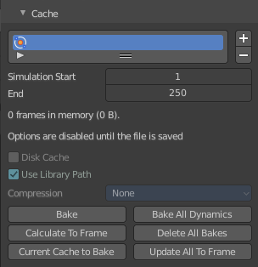
The soft body simulation can be cached in memory or stored on a drive. This improves real-time response and avoids unnecessary recalculation of particles. But creates also big files.
The cloth system uses a unified system for caching and baking (together with cloth and Emitter particle).
Important! The file needs to be saved after baking. When the file is not saved then some options are not available.
Important! The cloth settings becomes unavailable once the particle cache is baked. You need to remove the bake when you want to change the settings.

Hints
The simulation is only calculated for positive frames in between the Start and End frames of the Cache panel, whether you bake or not. So if you want a simulation that is longer than the default frame range, you have to change the End frame.
When an animation is played, each physics system writes each frame to the cache. Note that for the cache to fill up, one has to start the playback before or on the frame that the simulation starts.
The cache is cleared automatically on changes. But not on all changes, so it may be necessary to free it manually. For example if you change a force field.
The system is protected against changes after baking. If for example the mesh changes the simulation is not calculated anew.
The bake result can be cleared by clicking on the Free Bake button in the simulation cache settings.
A simulation can only be edited in Particle Edit Mode when it has been baked in memory. And cannot be edited if the Disk Cache is used.
If you are not allowed to write to the required sub directory caching will not happen. For example if your blend-file path is very long and your operating system has a limit on the path length that is supported.
Be careful with the sequence of modifiers in the modifier stack. You may have a different number of faces in the 3D Viewport and for rendering (For example when using subdivision surface). Then the rendered result may be very different from what you see in the 3D Viewport.

Caches List

The list of available caches. The caches have no name by default. Double click to add a name.
You can store and manage multiple caches at once for the same physics object. The active cache is the one that gets used.

Drag Handler
The two vertical lines at the end is a handler with which you can expand the list.

Search Field

You can expand a search field at the bottom of the list. Type in your term and hit enter to filter for your term.

Invert
Exclude the search term instead of searching for it.

Sort by Name
Sort the List by name.

Add New Cache
Add a new cache.

Delete current Cache
Deletes the selected cache.

Simulation start
The start frame of the simulation.

End
The end frame of the simulation.

Cache Step
Number of frames between cached frames.

Info string
An info string. Gives different messages, dependent of the status.

Disk Cache
Save the cache externally in a folder instead inside of the blend file. The cache of a baked simulation will be stored inside the blend-file when you save it. A folder named blendcache_[filename] will then be created alongside the blend-file. The blend-file must be saved first and then again.

Use Library Path
Share the disk cache when the physics object is linked into another blend-file.
When this option is enabled, linked versions of the object will reference the same disk cache. Otherwise linked versions of the object will use independent caches.

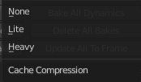
Compression
The compression level for cached files. It becomes available when Disk Cache is ticked

None
Do not compress the cache.

Light
Compression will optimize the speed of compressing/decompressing operations over file size.

Heavy
Compression will result in smaller cache files, but requires more CPU power to compress / decompress.


Bake / Delete Bake
Start baking. Once you have baked the cache the button turns into a Delete bake button. And allows you to remove the bake.

The baking progress can be seen in the footer. You need to be in Object Mode to bake.

Calculate To Frame
Bake only up to the current frame. Limited by End frame set in the cache settings.

Current Cache to Bake
Store any temporarily cached simulation data as a bake. Note that playing the animation will try to simulate any visible physics simulations. Depending on the physics type, this data may be temporarily cached. Normally such temporary caches are cleared when an object or setting is modified, but converting it to a bake will “save”it.

Bake All Dynamics
Bake all physics systems in the scene, even those of different types. Useful for baking complex setups involving interactions between different physics types.

Delete All Bakes
Free bakes of all physics systems in the scene, even those of different types.

Update All To Frame
Bake all physics systems in the scene to the current frame.

Goal subpanel


Use the motion from animations (F-curves, armatures, parents, lattices, etc.) in the simulation. The “goal” is the desired end position for vertices based on this animation.

Vertex Group
Use a vertex group to allow per-vertex goal weights (multiplied by the Default goal).

Goal Settings sub subpanel


Stiffness
The spring stiffness for Goal. A low value creates very weak springs (more flexible “attachment” to the goal), a high value creates a strong spring (a stiffer “attachment” to the goal).

Damping
The friction coefficient for Goal. Higher values give damping of the spring effect (little jiggle), and the movement will soon come to an end.

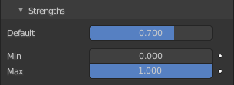
Goal Strength sub subpanel

Default
Goal weight/strength for all vertices when no Vertex Group is assigned. If you use a vertex group the weight of a vertex defines its goal.

Min / Max
When you use a vertex group, you can use the Minimum and Maximum to fine-tune (clamp) the weight values. The lowest vertex weight will become Minimum, the highest value becomes Maximum.

Edges subpanel

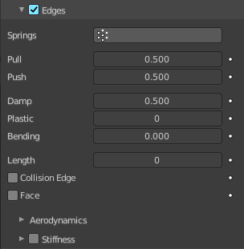

Use Edges
Allow the edges in a mesh object to act like springs. See interior forces.

Springs
Use a specified vertex group for spring strength values.

Pull
The spring stiffness for edges (how much the edges are allowed to stretch). A low value means very weak springs (a very elastic material), a high value is a strong spring (a stiffer material) that resists being pulled apart.
A value of 0.5 is latex, 0.9 is like a sweater, 0.999 is a highly-starched napkin or leather. The soft body simulation tends to get unstable if you use a value of 0.999, so you should lower this value a bit if that happens.

Push
How much the soft body resists being scrunched together, like a compression spring. Low values for fabric, high values for inflated objects and stiff material.

Damp
The friction for edge springs. High values (max of 50) dampen the Push/Pull effect and calm down the cloth.

Plastic
Permanent deformation of the object after a collision. The vertices take a new position without applying the modifier.

Bending
This option creates virtual connections between a vertex and the vertices connected to its neighbors. This includes diagonal edges. Damping also applies to these connections.

Length
The edges can shrink or be blown up. This value is given in percent, 0 disables this function. 100% means no change, the body keeps 100% of its size.

Collision Edge
Checks for edges of the soft body mesh colliding.

Face
Checks for any portion of the face of the soft body mesh colliding (computationally intensive!). While Face enabled is great, and solves lots of collision errors, there does not seem to be any dampening settings for it, so parts of the soft body object near a collision mesh tend to “jitter” as they bounce off and fall back, even when there is no motion of any meshes. Edge collision has dampening, so that can be controlled, but Deflection dampening value on a collision object does not seem to affect the face collision.

Aerodynamics sub subpanel

Force from surrounding media. See exterior forces for details.

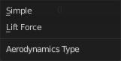
Type

Simple
Edges receive a drag force from the surrounding media.

Lift Force
Edges receive a lift force when passing through the surrounding media.

Factor
How much aerodynamic force to use. Try a value of 30 at first.

Stiffness sub subpanel
Add diagonal springs at quad faces. This stops quad faces to collapse completely on collisions.

Shear
Stiffness of the virtual springs created for quad faces.

Self Collision subpanel

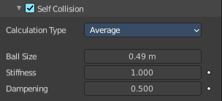
Note! Self-Collision needs Edges enabled!
Allow self collision and avoid self intersection. Every vertex is surrounded with an elastic virtual ball. Vertices may not penetrate the balls of other vertices. If you want a good result you may have to adjust the size of these balls.

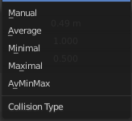
Calculation Type

Manual
The Ball Size directly sets the ball size.

Average
The average length of all edges attached to the vertex is calculated and then multiplied with the Ball Size setting. Works well with evenly distributed vertices.

Minimal / Maximal
The ball size is as large as the smallest/largest spring length of the vertex multiplied with the Ball Size.

Average Min Max
Size = ((Min + Max)/2) × Ball Size.

Ball Size
Fraction of the length of attached edges. The edge length is computed based on the chosen algorithm. This setting is the factor that is multiplied by the spring length. It is a spherical distance (radius) within which, if another vertex of the same mesh enters, the vertex starts to deflect in order to avoid a self-collision. Set this value to the fractional distance between vertices that you want them to have their own “space”. Too high of a value will include too many vertices all the time and slow down the calculation. Too low of a level will let other vertices get too close and thus possibly intersect because there will not be enough time to slow them down.

Stiffness
How elastic that ball of personal space is. A high stiffness means that the vertex reacts immediately to another vertex enters their space.

Dampening
How the vertex reacts. A low value just slows down the vertex as it gets too close. A high value repulses it.
Collisions with other objects are set in the (other) Collision panel. To collide with another object they have to share at least one common layer.

Solver subpanel

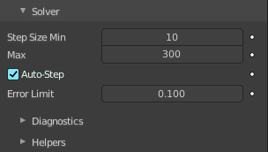
The settings in the Soft Body Solver panel determine the accuracy of the simulation.

Step Size Min
Minimum simulation steps per frame. Increase this value, if the soft body misses fast-moving collision objects.

Max
Maximum simulation steps per frame. Normally the number of simulation steps is set dynamically (with the Error Limit) but you have probably a good reason to change it.

Auto-Step
Use velocities for automatic step sizes. Helps the Solver figure out how much work it needs to do based on how fast things are moving.

Error Limit
Rules the overall quality of the solution delivered. Default 0.1. The most critical setting that defines how precise the solver should check for collisions. Start with a value that is half the average edge length. If there are visible errors, jitter, or over-exaggerated responses, decrease the value. The solver keeps track of how “bad” it is doing and the Error Limit causes the solver to do some “adaptive step sizing”.

Diagnostics sub subpanel


Print Performance to Console
Prints on the console how the solver is doing.

Estimate Matrix
Estimate matrix, split to COM, ROT, SCALE.


Helpers sub subpanel
These settings allow you to control how Blender will react (deform) the soft body once it either gets close to or actually intersects (cuts into) another collision object on the same layer.

Choke
Calms down (reduces the exit velocity of) a vertex or edge once it penetrates a collision mesh.

Fuzzy
Fuzziness while on collision, high values make collision handling faster but less stable. Simulation is faster, but less accurate.

Field Weights subpanel

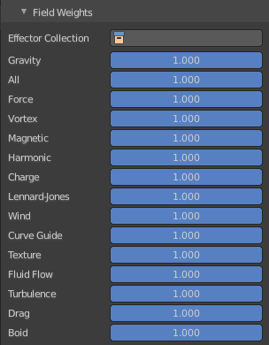
Adjust how strong other forces influences the soft body simulation.

